Summary of impacts of cold temperatures on emerald ash borer – implications for communities

Prepared by Rob Venette (US Forest Service), Lindsey Christianson (University of Minnesota) and Mark Abrahamson (Minnesota Department of Agriculture) - January, 2014

- EAB causes problems when it becomes very abundant in an area. Populations grow slowly until they reach a “tipping point” and begin growing rapidly – also killing many trees in a short time.
- EAB larvae generally freeze and die at temperatures between -20°F and -30°F.
- In areas where the coldest winter temperature is generally warmer than -20°F, cold mortality is unlikely to have much or any impact on the population increase of EAB (USDA Plant Hardiness Zone 5a and warmer).
- In areas where the coldest winter temperature is generally between -20°F and -30°F, cold mortality may delay the increase of EAB to levels that kill trees, but EAB should still be expected to reach tree-killing levels (USDA Plant Hardiness Zone 4a and 4b).
- In areas where the coldest winter temperature is generally colder than -30F, cold mortality may have a major impact on population increase of EAB – perhaps to the point of constraining populations below tree-killing levels (USDA Plant Hardiness Zone 3a and colder).
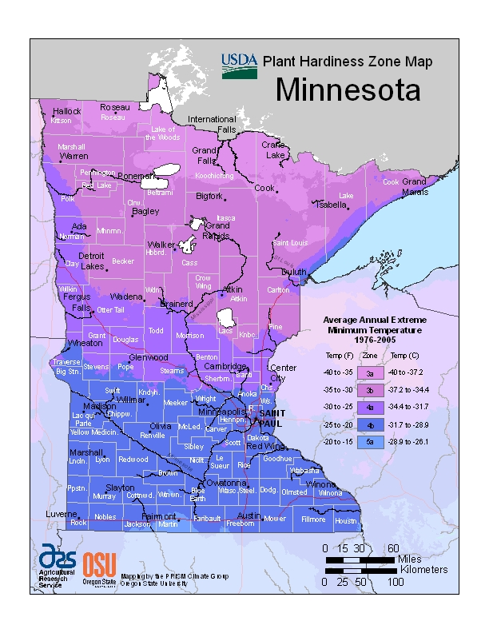
- Temperatures within known EAB-infested areas in Minnesota have been cold enough to slow EAB population growth but not enough to justify changing management plans. EAB populations should still be expected to grow to tree-killing levels in the near future without aggressive management.
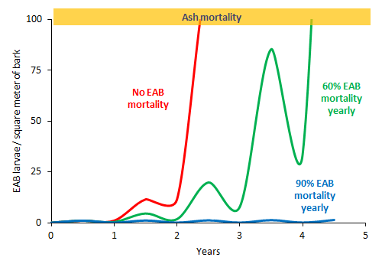
This is a hypothetical example of EAB population increase to illustrate the possible effects of yearly 60% mortality and 90% mortality.

